UI Notes

* the html/css websites we found on git varied a bit because different people worked on different things
* they’re saved as .png files to preserve transparency
* we did our best to create as many of the UI elements that we could, but if anything is missing/needs to be created along the way, just shoot us a message!
* and don’t feel obligated to use anything you feel would work better as text
* a large part of our inspiration was drawn from Dropbox’s layout

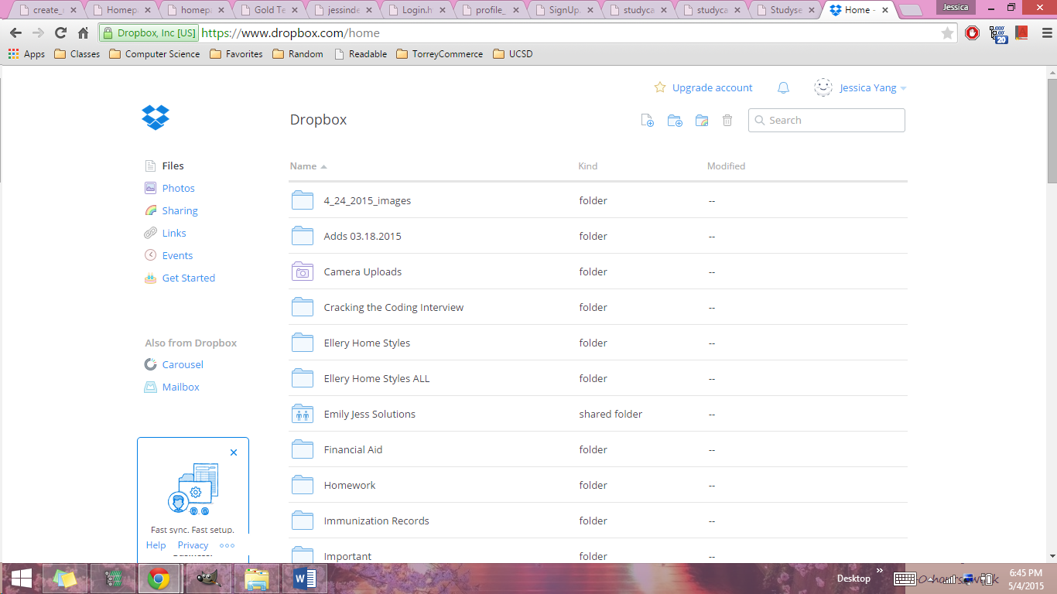

* it has a very clean interface and doesn’t require too many images

FONT

* Font Type: the font they use (and being used here) is “Segoe UI”, which we think will work best for our site too
* Font Color: instead of making it completely black, we were thinking of make it more of an off black/gray (less harsh) like #363232

COLORSCHEME

* for the color scheme, ideally the site background would be white (#ffffff)
* and the topbar will be a lighter blue (##0099FF)

SIDEBAR

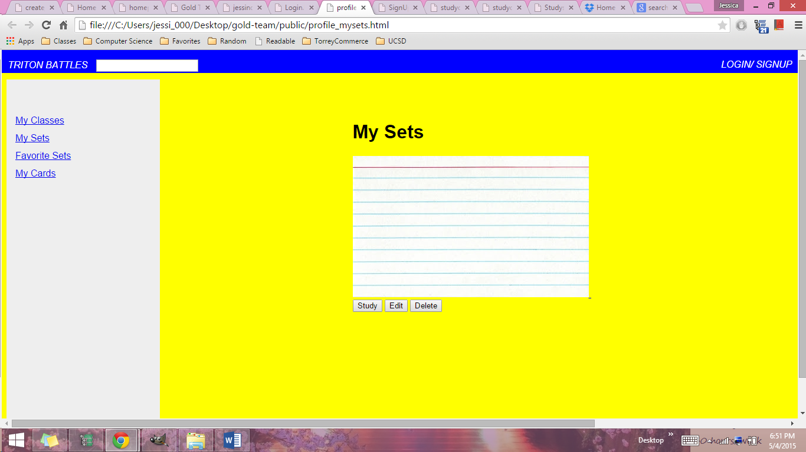

* For the sidebar, maybe just links like Dropbox (creating a sidebar image with different parts is a bit difficult)
* Like this:
* 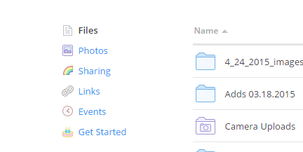
* thanks for reading! ☺